Chapter 14, Solution 93.

Consider the circuit as shown below.

+
_
V_{s}
C
R
C
R
+
_
V_{o}


V₁
V₂

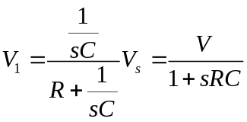
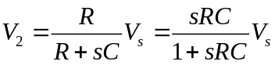

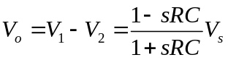
Hence,
